

9/8/2016

# Table of Contents

Table of Contents 1

Overview 6

Bit O’ History 6

Who, What, When, Where, and Why it Started 6

Personnel 7

Nanocon Manager 7

Advertising Manager 7

Gaming Quartermaster 7

CCG Tournament Coordinator 7

Concessions Manager 7

Czar of Propaganda 7

Front Table Manager 8

Event Services Manager 8

RPGA Coordinator 8

Speaker / Workshop Coordinator(s) (IDiG) 8

SIS Liaison 8

Vendor Liaison 8

Video Game Area Manager 8

Website Manager 8

Minions 9

How Its Run 10

Meetings 10

Structure 10

Spacetime 10

Before the Convention 10

Setup 10

During the Convention 10

Night Guard 10

Canceled Events 10

Resolving Disputes 10

Chain of Command 10

After the Convention 10

Mass Thank you 10

Cleanup 10

Wrapup Meeting 10

The Good, the Bad, the Ugly 10

Thank You 11

Mass Thank You 11

Example Letter 12

Other Info 14

Nanocon 7 Notes 14

Nanocon 8 Wrap Up notes 16

Officers 18

Approval 18

New Roles 18

Schedule 19

Typical Schedule Items 21

Games 21

SIS - Society in Shadows 21

Magic the Gathering 21

Role Playing Games 21

Board Games 21

Miniatures 21

War Hammer 40k 21

D&D 21

Pathfinder 21

Twilight Emporium 21

Adventure in a Con 21

Vendors 21

ACME 21

Hobby Town 21

Flash Bax 21

Artists Alley 21

Dragon’s Den 21

Silver Gryphon Games 21

Fantasy Trading Post 21

Website 22

Committing Changes 22

SVN Folder Structure 22

Live Website 22

Managing the Website 22

Before Nanocon 25

After Nanocon 25

Deadlines 26

Rules 27

Convention 27

Cabinet 27

Nanocon Attendee Policy 27

Finances 29

Funding 29

Breakdown 29

Expenditures 29

Profit 29

Booklets 30

Personal Coordination 30

Event Coordinator 30

Czar of Propaganda 30

Web Master 30

Concessions Manager 30

Advertising Manager 30

Content 30

Layout 30

Printing 31

Propaganda 32

Posters 32

Advertising Locations 32

Guidelines 32

Table Signs 32

Types 33

Creating the Badges 33

Lanyard 33

Badges 33

Badge Sizes 33

Advertising 34

Locations 34

Vendors 35

Fees 35

Setup 35

Badges 35

Tabs 35

Advertisement 35

Day of Event 35

Rules 35

Contracts 36

Forms 37

Online 37

Event Form 37

Vendor Form 37

Paper 37

Contracts 37

Dakota Prairie Playhouse 37

Clubs 38

Gaming Club 38

Anime Club 38

Photography Club 38

Events 39

Submission Form 39

Website Integration 39

Sched.org 39

Nanoman 40

Nanoman 1.0 40

Image 40

Background Information 40

Creator 40

Date of Creation 40

Copy Right Info 40

Tag Line? 40

Nanites 40

Nanoman 3.0 41

Image 41

Background Information 41

Creator 41

Date of Creation 41

Terms of Use 41

Contacts 42

Template 42

Sioux Falls 42

Dragons Den 42

Rainbow Sports Cards and Comic Books 42

Hobby Town 42

Last Stop CD Shop 42

Gamestop (Charity Raffle??) 42

Universal Bits & Games (Charity Raffle) 42

Galaxy Gaming 42

Brookings 42

Brost’s (Game store) 42

GameStop 42

Outside o.o 42

Reaper Minis 42

Rightstuf! :D:D:D:D (dis fur sure; full page trade for charity raffle items) 42

Six Stones 42

http://www.sixstones.com/ 42

Madison 43

Diary Queen 43

Sunshine? 43

Shopko 43

McD? 43

Lazor Tag :D 43

LOOPYS 43

Hotel Information 43

Super 8 Madison 43

AmericInn Lodge & Suites 43

Lakes Lodge 43

Camp Lakodia? 43

SVN 44

Overview 44

Permission to Access 44

Setup 44

Essential Information 44

Getting on Computer 44

SVN Basics 46

Modifying Files 46

Upload / Commit changes 46

Do’s and Don’ts 47

Don’t 47

Do 47

File Structure 47

Email Policies 49

Signature 49

Details 49

Etiquette 49

Emailing on Behalf of Nanocon 49

Contacts 49

Concessions 50

Concessions (food) 50

Jack’s Meat Locker 50

Pizzas (from wholesaler @ $2/pizza) 50

Sam’s Club 50

Sunshine 50

Concessions SOP 51

Tab Sheets 51

Safe Drops 51

Setup 51

Pizza 52

Checks 52

Coffee 52

Cleaning 52

Equipment 53

RPGA 53

Magic 53

Video Games 53

Reaper 53

Other - Events 53

Concessions 53

Convention Hall 53

Convention Hall Layout 54

Rooms 54

Primary Convention Room 54

Main Hall 54

Theatre 54

Concessions 54

Updating the Layout 54

Maps 55

Main Lobby 55

Main Hall & Theatre 56

Areas 57

Front Table Area 57

Game Consoles 57

Before Nanocon 57

At Nanocon 57

After Nanocon 57

SIS 57

Role Playing Gaming Area 57

CCG Tournament 58

Gaming Area 58

IDiG 59

Speakers 59

Hotel & Board 59

Presentation 59

Bio 59

Contracts 59

Scheduling 59

At the Con 59

Minions 59

Bible Writing Conventions 61

Referring to People 61

Formatting 61

Updating 61

Authors 62

Title Page 64

# Overview

Nanocon is an annual gaming convention run by the Dakota State University Gaming Club. It is held on the first full weekend (Friday through Sunday) after the first Thursday of November.

Our primary goal is to provide a high quality gaming experience for all attendees by hosting several events of various types. Each event is overseen by members of the DSU Gaming Club and/or their designated attendees. Events include, but are not limited to: collectible card games, Society in Shadows live action role playing, tabletop role playing, tabletop miniature war gaming, speaker presentations and panels, figure painting, video games, and board games.

Secondary to this is to make the basic operating cost of the convention back through various means. This includes, but is not limited to: concessions, pay-to-play events, the sale of personalized badges, and the sale of convention t-shirts.

## Bit O’ History

### Who, What, When, Where, and Why it Started

Need history here!

# Personnel

There are several essential management positions for Nanocon. Job descriptions include what to do before, during, and after Nanocon on their respective pages. Not all positions have all three job description areas, but all positions must be filled. All positions may have subordinates chosen by the person filling the position.

## Nanocon Manager

The Nanocon Manager is responsible for coordinating the con, delegating tasks, and running the weekly meetings, as well as keeping the world turning.

## Advertising Manager

The Advertising Manager is responsible for getting advertising from area businesses, and distribute the Nanocon Pamphlets to said businesses. This person will have to work with the Website Manager, Czar of Propaganda, Vendor Liaison, Artist Alley Manager, and the Front Table Manager. The relevant sections are Advertising and Contacts.

## Gaming Quartermaster

The Gaming Quartermaster is responsible for keeping track of the games loaned to us from Gaming Club. This person is also responsible for the general gaming area. See the Gaming Area section for more information.

## CCG Tournament Coordinator

The CCG Tournament Coordinator, is also known as the Collectable Card Game Tournament Coordinator. This position will be responsible for contacting outside organizations to host CCG events, pass out the event organizer packet to said organizations, and sending thank you letters to said organizations. The positions they work with are Czar of Propaganda, On Site Schedule Manager, and the Nanocon Manager. For more information, see CCG Tournament, Contacts, and Thank You sections.

## Concessions Manager

The Concessions Manager is responsible for the Concessions Area. This person will be responsible for scheduling people to work the kitchen, keeping track of tabs, and getting the supplies. For more information, see Concessions and Contacts sections.

## Czar of Propaganda

This person is in charge of all the propaganda. They are to create a theme to work around each year. They are responsible for creating all the posters and propaganda. This position works with the Website Manager and Advertising Manager. Look at the following sections: Propaganda

## Front Table Manager

The Front Table Manager is responsible for handing out lanyards, booklets, and pointing people towards the right area. This position will work with Event Services Manager. For more information, see Front Table Section and the Convention Hall Layout Section.

## Artist Alley Manager

The Artist Alley Manager is responsible for finding artists and coordinating the three tables at the con. They will keep in contact with the artists, schedule the artist block at the con, and act as a go-between for any questions. This position will work with the Website Manager, Czar of Propaganda, and artists in the community. For more information, see the Artist’s Alley section.

## Event Services Manager

The Event Services Manager is responsible for making sure that an up to date, accurate and detailed events are available at all times. This position is also responsible for updating the schedule during the nanocon event. The people they work with are the Website Manager, IDiG Coordinator, SIS Liaison, Video Game Area Manager, and Czar of Propaganda. For more information, check out the Schedule, Propaganda, Thank You, Contacts, and Advertising sections.

## RPGA Coordinator

The RPGA, or role playing gaming area coordinator, is responsible for the back corner of the convention area. They get six tables, and are responsible for making sure that all modules are present and making sure the area is kept clean. Relevant sections for this position are Role Playing Gaming Area and Convention Hall Layout.

## Speaker / Workshop Coordinator(s) (IDiG)

IDiG, or Integrated Design in Games is responsible for acquiring and confirming guest appearances. They are responsible for taking care of the guest speaker. For more information, see the IDiG section.

## SIS Liaison

The SIS Liaison, or the Society in Shadows liaison, is responsible for getting in contact with Six Stones, and acting as their liaison.

## Vendor Liaison

The Vendor Liaison is responsible for making sure that the vendors know what they are doing, and how to go about it. Relevant sections for this position are Vendors and Convention Rules.

## Video Game Area Manager

This person is responsible for keeping track of all gaming consoles, projectors, cords, projection screens and providing guidance to players. For more information, see the Game Consoles section.

## Website Manager

The Website Manager’s sole duty is to make sure that the website stays up to date and to adjust it as needed. The Website Manager will have to collaborate with the Czar of Propaganda and the Schedule Manager. For more information, see the Website section.

## Minions

Minions are people who are assigned to speakers and VIP’s. Their primary job is to become their shadow and provide the speaker or VIP with whatever they need. There are no relevant sections for this position.

# How Its Run

This is a general overview of how the convention is run. This only the broad overview of how events happen, and what to expect—each convention will have its own challenges.

## Meetings

### Structure

### Spacetime

## Before the Convention

### Setup

## During the Convention

### Night Guard

### Canceled Events

### Resolving Disputes

### Chain of Command

What if the Manager doesn’t show up? Who’s in charge? What if the event coordinator doesn’t show?

## After the Convention

### Mass Thank you

### Cleanup

## Wrapup Meeting

### The Good, the Bad, the Ugly

# Thank You

This section will discuss how to format thank you letters, who they should be sent to and when they should be done.

## Mass Thank You

This a generic thank you that will be posted on the website on the main page. A sample is below from Nanocon 8:

## Example Letter

Nanoman says thank you.

Nanocon has once again come and gone, and before I begin my extended hibernation to await Nanocon 2011 I must say thank you to the many, many people who made this year amazing.

Thank you to Allen for organizing. Thank you to Czar of Propaganda Travis, That Guy John and Laci for posters, programs, badges and advertising. Thank you to Adam for organizing the concessions. Thank you to Galen and Casey for helping vendors and guests. Thank you to Adam and Adam, Gene, Sean, Shaun, Dana, Alex, Jenkins, Steven and all the NPC for months of effort.

Thank you to Kat and Jill for support and patience.

Thank you to Nanocon’s featured guests: Fredd, Thane, Jeff, Jeff and Jeff, Chris, Matthew, Clara and Kevin for sharing their knowledge, ideas and experiences (and class activities). Thank you to Josh, Sean, Steven, and Brian for sharing their vacation slideshow.

Thank you to the College of Arts and Sciences and Dean Forbes-Boyte, the college of Business and Information Systems and Dean Halverson and President Knowlton’s office for their continued support to bring these great guests to play with us at Nanocon.

Thank you to Jeff and Steve for hosting speakers and helping them enjoy the weekend.

Thank you to Silver Gryphon games, Dark Matter Anime, Weapons of the Wood, Ruby, Flashbax, Acme Comics and Collectibles, and Hobby Town for joining in.

Thank you to Society in Shadows for playing. Here’s looking forward to seeing all of you next year.

Thank you to Paul for setting up sound for our speakers.

Thank you Alexis and Kat for the first appearance of the velvet room at Nanocon.

Thank you to everyone who pushed, carried, set up, broke down, swept, scrubbed, stacked and otherwise did the before and after work of setting up Nanocon.

Thank you to the DSU Student Senate for your help with concessions.

Thank you to Misho, Jonno, Gary, Bob, Tyson, Ben, and all the other lifetime members who came back to play more games.

Thank you to Kelly and Sandy for letting Nanocon use the stage area.

Thank you to Donna for working with Nanocon to make the DPP an amazing place for a con.

Thank you to Lakes Lodge and AmericInn for setting aside rooms and giving deals to people coming to Nanocon.

Thank you to everyone who ran a game.

Finally, thank you to everyone who came through the door, painted a figure, played a game, listened to a speaker, or just wanted to look around. You are Nanocon, thank you thank you thank you!

Until we meet again on November 4th, 2011 remember PLAY MORE GAMES AND HAVE MORE FUN,

NANOMAN

# Other Info

This is info about Nanocon that needs to be incorporated into this bible, but currently doesn’t have a home.

## Nanocon 7 Notes

On campus adds: Need more info on what they want.

Print cost?

Known event:

* SiS
* RPGA - DnD
* Magic
* Warhammer 40K
* Warlord/CAV
* Paint & Take
* Fig Paint contest
* Fantasy Flight Guy
* Showdowrun
* Vamp
* Apples to Apples - Kat
* Game Design Contest
* Diplomacy - Lewis
* Munchkin - Kat

Vendors: - All confirmed

* Hobby Town
* Weapons in the Wood
* Acme

Speakers:

* Jeff Tidball
* Richard Dansky

Other:

* + Fred
  + Movies (Rocky Horror Picture Show)
  + Video Games - Possibly SooFoo Gamers?

Suggested events:

* Poker
* Magic Deck Tech w/ Casey
* Risk
* Munchkin
* Dissent
* Arkum Horror
* Betrayal
* Sorry
* Monopoly
* Yatzee
* Uno
* Phase 10
* Brian Hegdall - ASL
* SCA
* Five Stones

TODO:

* Sign ups for work
* Schuduling for work
* Line up consession equipment
* Talk to SCA
* List of where the big posters go
* Put together menu and prices
* States attourney
* Talk to AmericInn and Super 8
* Reserve rooms for people
* Layout
* Talk to Gary's about baked goods
* Scott - Sunshine
* High schoolers and baked goods
* reserve equipment and list
* Large poster
* Next year's dates and ad
* Nail down schedule for booklets
* School paper add
* KDSU
* Talk to Steve about recycling
* Get more trash cans
* Website
* Photographer
* Community boards - Adam, Glenn
* Entry sign
* Sign in table
* Signage
* Nametags

## Nanocon 8 Wrap Up notes

AllStudent/AllStaff notification

Prices for paid events (SiS)

Power strips

Paper for counter/Thane tables

Talk to the drama department about theater scheduling

Pens

Move Rock Band to hallway

Have one hallway for SiS - weather dependent

Warhammer - couple people interested. Try to get them back next year.

Computer Club - Wants to come back next year. Need to keep in contact with them for next year.

Around noon Thursday - meet at enterance high school

Need to get paperwork done to get sales tax back for Sam's Club

Nanocon Shirts for Staffs - pre-ordered and have to paid. If you get a shirt you are expected to work.

Need to talk vendors - talk to rainbow and invite them, confirm with everybody

Get schedule filled up

Need to get fliers, buisness cards and booklets done and send them out asap

Meetings every 3 weeks or once a month

Make up a group for Nanocon on Yahoo

Next meeting - Second Tuesday of December 8th

The Good:

* SiS
* Pizza
* Concessions
* video Games
* High School kids helped a lot of concessions - quite a few of them wanted to come back next year. Going to cut them a check of $250 this year.
* Dragons Den - running Magic was money well spent
* Sis loves Nanocon, loves being here, especially when the weather is great

The Bad:

* Concessions advert
* Big Menu posted on the wall
* Recyling bins - need to get them to there next year
* Need to put out the word that we're looking for people to fill the schedule - expand the booklet
* Tabs - people should do something for nanocon to hold a tab. You have to be a Gaming club member before nanocon to get a tab.
* Chili - we do need the hot food item. Homecooked is too expensive. Convert to Canned Chili.
* Need someone up at front for guests or a sign saying "talk to consessions" or "talk to 'blank'"
* Strange smell out back - keep eye out
* Raffle - have SiS run their own raffle. Do we want to expand and add a raffle for us?

The Ugly:

* Web site up a lot earlier - Goal is to have start of website up before Vermincon. Pre-registration online. need to look at domain, hosting, and whatnot.
* Computer Club - talk to computer club and keep them in contact
* soofoo gamers - invite them this , if Brandon is on, then we'll do it for next year
* Booklet - Needs to be done several months beforehand. Get advertisement earlier. Up the prices for advertisement. Proofreading.
* SRA/SCA - cutting them

# Schedule

As of Nanocon 12 (2014), we will be using Sched.org to keep track of our events.

The online event schedule will contain the current and most up to date information regarding the events.

Places to find previous Schedules :

2014 - <https://nanocon122014.sched.org/>

2015 - <https://nanocon2015.sched.org/>

Critical areas to find events for / People to Cover:

* War Hammer events
* Video Games
* RPGA
* Paint and Take
* Game Design Students showing off their games
  + Typically in theater
  + Tried to move it to main hall in 2015
* Computer games

Signup sheet

Be sure to have locations on there!!

Say all events should wrap up around 5pm the last day

Say all events start up around 5pm the first day

Converting from sched to booklet

1. Download the latest sched schedule from the sched site.
2. Open up the file, remove the first 5 rows
3. Then remove what now should be the 2nd and third row.
4. Save it as a csv file named “sched final”
5. Run the following command in command line in the Schedule folder:
   1. Php schedtoBooklet.php > bookletDescriptions.txt
6. Take text from file and paste it into a word document
7. Use the no spacing formatting
8. Search for this, with wildcards on : \<b\>(*)\</b\>
9. Replace with this : \1
   1. With formatting of 13 px and bold font
10. Next search for this, with wildcards on : \<i\>(*)\</i\>
11. Replace with this : \1
    1. With formatting of 12 px, italic and 6px spacing after paragraph

* Before Nanocon
  + Schedule Gaming Club members to run events.
  + Find outside people/organizations to run events at Nanocon.
  + Schedule events.
* At Nanocon
  + Give all event organizers their respective event organizer packet.
  + Make sure all event organizers are aware of the event procedure.
  + Make sure all event organizers are at their designated feature table at their designated time.
  + Field any schedule changes, and alert the On Site Schedule Manager of any changes (including new events).
* After Nanocon
  + Send Thank You letters to all people/organizations who ran events.
* At Nanocon
  + Post the day’s schedule of events for various areas of Nanocon.
  + Work with the Speaker and Workshop Coordinator, CCG Tournament Coordinator, RPGA Area Coordinator, SIS Liaison, Guest Event Services Manager, Gaming Club Event Services Manager, and Video Game Area Manager to post any schedule changes in their respective areas.

# Typical Schedule Items

## Games

### SIS - Society in Shadows

### Magic the Gathering

### Role Playing Games

### Board Games

### Miniatures

### War Hammer 40k

### D&D

### Pathfinder

### Twilight Emporium

### Adventure in a Con

## Vendors

### ACME

### Hobby Town

### Flash Bax

### Artists Alley

### Dragon’s Den

### Silver Gryphon Games

### Fantasy Trading Post

# Website

## Committing Changes

You may not upload an entire project onto the SVN, you need to put it into a zip file first. This way we can avoid having a bunch of files on the SVN. The zip file must have the language used for the website (ASP, PHP, Ruby, etc.) somewhere in the name of the file.

## SVN Folder Structure

Each year the website will have to create a static version of the website, zip it up, and put into their respective folder for the year. It will have the name of Static Pages.zip.

## Live Website

The live website will follow a similar structure to the SVN. The only real difference between them should be that the files should be zipped on the SVN.

## Managing the Website

Need to enable these options

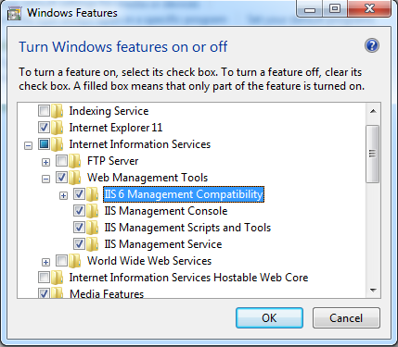

After done installing, open up MMC.exe :

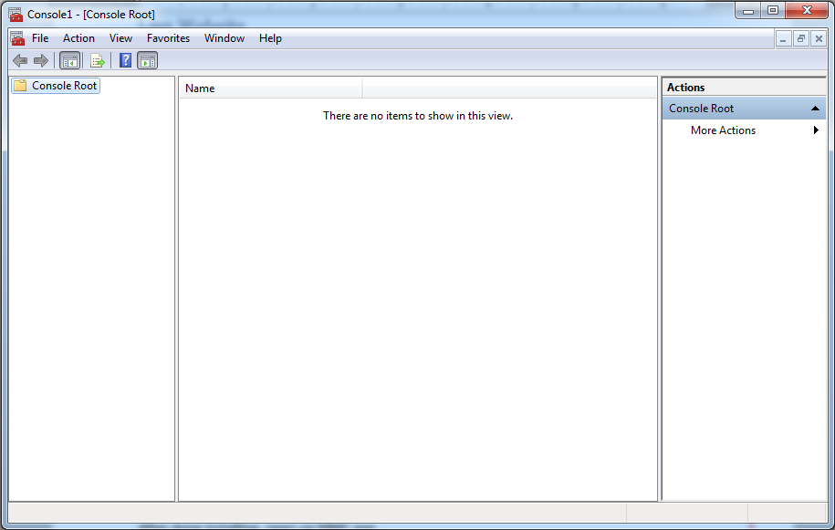

Go to File -> Add/Remove Snapins

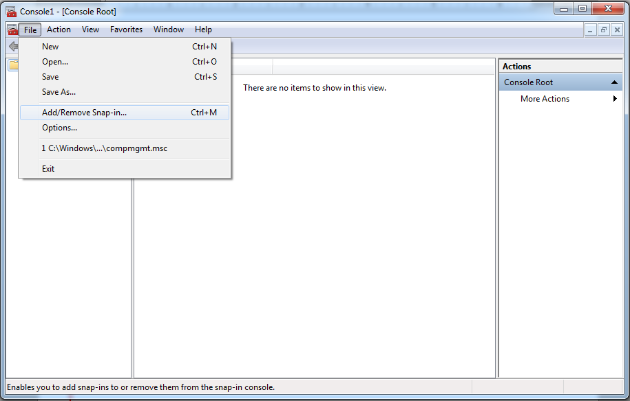

Add the IIS management console.

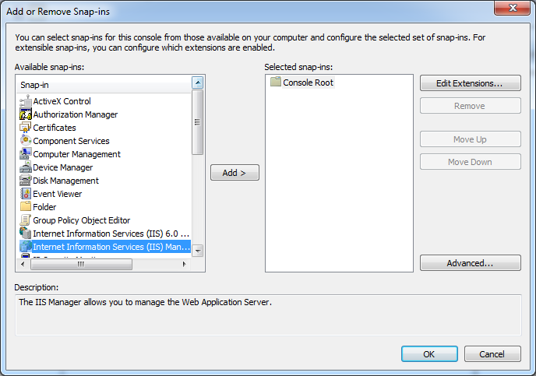

## Before Nanocon

Update the website as necessary.

Schedule

File Downloads

Hotel availability

Description

Map and directions

Work with the Czar of Propaganda for new website artwork.

## After Nanocon

Update the website as necessary.

Mass Thank You

# Deadlines

The booklet needs to be printed out the week of the con, this way all changes can be put into the booklet.

The online event schedule will contain the current and most up to date information regarding the events.

The events in the booklet will be the complete list of events from the site on Monday of the week of Nanocon

* Guests – Start of Fall Semester (hopefully!)
* Events (non-club) – End of October
* Events (club) – Mid-October
* Vendors – Middle of September
* Advertising – Start of October
* Booklet – October 31st
* Event Submission – October 28th
* Propaganda – Before Spring Semester Ends
* Vendors
  + Invites sent in April
  + Need to be finalized on September 30th
* Floor Plan – Finalized by Oct. 14

# Rules

## Convention

* All events require an event ticket to participate. Tickets can be picked up at the ticket booth across from concessions.
* While Nanocon is a free convention, there may be some events that are pay to play.
* Please do not use designated featured areas for non-scheduled games and events.
* Tables not designated as featured areas can be used by anyone for personal games and events.
* Updates to the event schedule will be posted throughout the convention hall as well as at the ticket booth.
* Nanocon Staff reserves the right to refuse service to anyone for any reason, as well as ask people to leave the convention.
* Minors under the age of 13 must be accompanied by an adult, or will be asked to leave the convention.

## Cabinet

* Only one game will be checked out at a time per person.
* All games must be returned to the cabinet at the end of use.
* Please respect our property so others can enjoy these games, too.
* Please help keep the cabinets clean and organized so that others may easily find the games they wish to play.
* Keep small game pieces away from small children to avoid injury
* If you need assistance with game rules, please ask a Nanocon staff member.
* Play at your own risk. We are not responsible for injury or humiliation experienced while playing these games.

### Nanocon Attendee Policy

Entering the con hall constitutes the acceptance of the following policies. These policies are not all inclusive and the Nanocon staff retain the right to remove you from the con for reasons expressed or not.

1. Any persons under thirteen (13) years of age MUST be accompanied by a parent or guardian inside of the con hall. No exceptions. Any minor found in violation of this policy will be removed, with a call to a parent or guardian to retrieve them.
2. Practice good hygiene. Nanocon staff and Dakota State University (hereby referred to as “DSU”) work hard to keep the con hall clean and usable.
3. Fighting is not allowed in or around the con hall, or anywhere on DSU property. Those in violation of this policy will be removed immediately.
4. Theft is illegal. Law enforcement will be contacted. Nanocon staff retains the right to detain your persons until law enforcement has arrived to handle the situation.
5. Sexual harassment is not allowed. Any confirmed reports of sexual harassment will result in an immediate banning from Nanocon and the con hall.
6. No destruction of property will be tolerated. This will result from an immediate removal from the con hall. At the discretion of the offended persons, you will be liable to provide monetary compensation.
7. DSU is a dry campus. Nanocon and its staff will not tolerate alcohol in or around the con hall.
8. Sleeping in the con hall is strictly prohibited.
9. Any and all applicable laws must be upheld while in attendance of Nanocon.

# Finances

The Nanocon budget is usually well balanced.

## Funding

When we first started we usually used the Gaming club budget. But during the 2012 and 2013 we were able to get a separate fund just for Nanocon. During the 2012 year we were able to get $$$ amount and the next year we were able to get $$$ amount.

## Breakdown

The funding we get is usually broken down into two different categories, IDiG and Concessions.

IDiG funds are usually %%% of the total Nanocon budget. The rest usually goes towards Concessions. We do have to pay

## Expenditures

Our biggest expenditure is in concessions, which also acts as the biggest profit for Nanocon

## Profit

# Booklets

We have been creating Nanocon Booklets for the last xxx years. In the booklet we can find all the events, the menu, ads from our sponsors, and the rules and code of conduct for the con. The booklet requires the collaboration of many people to create.

## Personal Coordination

In order to get the booklets all figured out, you need these people to collaborate.

### Event Coordinator

Ensures events are correct.

### Czar of Propaganda

It is the responsibility of the Czar of Propaganda to create the cover Art. It is also the responsibility of the Czar of Propaganda to create the “See you next year” back page for the booklet.

### Web Master

Grabs event info from the Sched.org site.

### Concessions Manager

Provides the menu details for the booklet.

### Advertising Manager

Provides the ads for booklet.

## Content

The first page of the booklet should be a generic welcome statement to Nanocon. Followed by the menu. Then we have the rules and policies section of the booklet. Then the speaker section of the booklet. After all that, you can start inserting ads into the booklet, limit it to two pages of ads. Then you can insert the events for Friday starting at 5pm. After all of those events, we can insert some more ads, once again no more than 2 pages. Then we can continue on to Saturday’s events, starting at 6am and ending around 12. Then some more ads, and then Sunday’s events. Finally add any remaining ads. If the number of pages isn’t a multiple of 4, then you can add a Notes and Autograph section to the back of the booklet, until the pages are a multiple of 4. Then at the back of the booklet, we have a “See you next year” with the dates for the next nanocon.

### Layout

The booklet is 5.5” x 8.5”. You will be using the template provided in the template folder.

#### Credits

#### Ads

##### Guidelines

Vendors are allowed (and encouraged) to advertise in the Nanocon booklet.

##### Pricing

$25 for half a page.  
$50 for a full page.

### Printing

Who usually prints these? Who puts them together? Where does the money come from to print these? Is it revenue from the Ads?

Contact Details for the people who print it.

# Propaganda

* Before Nanocon
  + We will be creating propaganda themes a year in advance, so posters will be available at the con.
  + Finalize all propaganda to be used for this year’s Nanocon.
    - Small poster
    - Large poster
    - Con Booklet
    - Con Badges
    - Con Signs
    - T-shirt design
    - Menu
    - Schedule Template
    - Event tickets
    - Next Year’s Poster/flyer
  + Work with the Website Manager for new website artwork.
  + Work with event coordinators and Nanocon Manager to create event tickets.

## Posters

This is an overview of posters for Nanocon.

### Advertising Locations

See.

### Guidelines

Before printing or proceeding with the design, present it at a Meeting for approval and feedback.

## Table Signs

These are put over tables that have scheduled events. The ones closest to the entrance should be placed the highest, while the ones closer to the back should be placed lower, this way who ever walks in, will be able to find where they need to be.

|  |  |
| --- | --- |
| Types | |
| C:\Users\DSU\Desktop\Nanocon\Nanocon 11\Propaganda\Badges\vendor badge.jpg | These are printed on green paper. The vendor’s name should be on the badge. |
| The staff badges are usually printed in Orange. | C:\Users\DSU\Desktop\Nanocon\Nanocon 11\Propaganda\Badges\staff badge.jpg |
| C:\Users\DSU\Desktop\Nanocon\Nanocon 11\Propaganda\Badges\guest badge.jpg | These are usually printed on white paper. There should be a number system (guest tracking). |
| Speaker badges are usually printed on blue paper. They can also have the speaker’s name on it. | C:\Users\DSU\Desktop\Nanocon\Nanocon 11\Propaganda\Badges\speaker badge.jpg |
| C:\Users\DSU\Desktop\Nanocon\Nanocon 11\Propaganda\Badges\bizkit.jpg | Unique badges are usually printed on purple paper. They can be completely customized. |

# Creating the Badges

The badge is composed of three items, the Lanyard, the badge holder and the badges themselves.

## Lanyard

The first two we need to order from Central Business Supply, Inc. here in Madison. Below are the two items that we need to order.

|  |  |
| --- | --- |
| http://content.etilize.com/images/500/11960732.jpg?rwndrnd=0.22692858264781535 | **Baumgartens Standard Cord Lanyard**  The lanyard product ID is BAU68909. They do not come in packs, but each one is worth $0.69 as of 8/22/2014. |
| **Baumgartens Proximity Badge Holder**  The badge holder product ID is BAU47820. They come in packs of 50. Their price as of 8/22/2014 is $16.49 per pack. | http://content.etilize.com/images/500/11960788.jpg?rwndrnd=0.05210239766165614 |
| *(Pictures are from their website)* | |

## Badges

The third item we have to create ourselves. The lead artist is responsible for creating the look and style of the badge, which should tie back into the year’s theme. There are 5 types: Vendor, Staff, Guest, Speaker, and Unique. The on the side shows you the characteristics of each badge type.

## Badge Sizes

The max size of a badge can be 3.5” x 2 3/8”.

# Advertising

## Locations

Refer to Contacts Section

# Vendors

## Fees

There are no vendor fees, however we do ask they donate an item of some sort to the Charity Raffle.

## Setup

### Badges

Contact us for the number of badges you need, along with the name of the business, and name of the personnel as you wish it to appear on the badge.

### Tabs

Vendors are allowed to have a tab at the concessions counter. The tab must be paid before you leave the event. Any vendor who fails to pay their tab before leaving the event will not be invited or allowed back as a vendor.

### Advertisement

Vendors are allowed (and encouraged) to advertise in the Nanocon booklet. The booklet is 5.5” x 8.5”.

Ad space is available at the following rates:

$25 for a half page ad

$40 for a full page ad

Payment is expected by the end of the convention.

### Day of Event

Doors open for vendor setup at 1 PM.

There will be people available to help unload and set up your booth.

## Rules

Vendors are not allowed to sell food or drink, as that is how we pay for the convention.

Any vendor who does sell food or drink will not be invited or allowed back as a vendor.

If you wish to advertise, please send the advertisement you wish to run to this address.

## Contracts

* Before Nanocon
  + Confirm what vendors will be attending.
  + Send attending vendors confirmation letter detailing Nanocon rules concerning vendors, and offering advertisement in the Con Booklet.
* At Nanocon
  + Gather people to help unload and set up as needed.
  + Inform vendors of their respective booths.
  + Inform vendors that they may run a tab at the concessions counter.
* After Nanocon
  + Send Thank You letters to all attending vendors.

# Artist’s Alley

First come, first serve in regards to artist spots.

Artists that want to participate in artist alley must include some game art (videogames, board games, DND etc.) in their stock. (Drawing or craft). Examples of art must be included in request.

Requests will be sent to Artist Alley Head and will be regarded and will be either accepted, denied, or added to a waitlist.

Artists have 2 weeks prior to the con to confirm their spot. If they are unable to make the con, the next person in the waitlist will be contacted to take their place. If you fail to contact 2 weeks prior, the next person on the waitlist will be contacted.

# Forms

This section will house all the information regarding forms and contracts both online and off.

## Online

### Event Form

This form will be used online. Whoever wants to setup an event will have to fill out this form.

### Vendor Form

The vendor contract is something that you will need to get from the University.

## Paper

### Contracts

### Dakota Prairie Playhouse

This is where we hold the convention. We need to make a contract with them to rent out the entire facility. They usually charge us $50 dollars a day for the event. The contact person will be the Gaming Club Advisor. You use his or her personal phone number on the contract. We need to create this contract by DD/DD/DDDD, otherwise we will not be guaranteed the space.

# Clubs

Nanocon receives help from local clubs on campus. We try to work with as many as possible, but please check with each club every year to verify their participation, and don’t be afraid to branch out!

## Gaming Club

Games

## Anime Club

Front Desk

## Photography Club

Photography Area

### Game Design Club

Drama club

# Events

## Submission Form

## Website Integration

During Nanocon 12, we tried out an online service that makes it easy and convenient for convention goers to sign up for events that they will be attending.

## Sched.org

This is an online website that we first tried out in Nanocon 12. It is an online event scheduler that is very user friendly towards the convention guests. It costs $200 to use. There will be a WordPress plugin that will enable us to automatically submit events to the service. It will also automatically grab the event info and parse it to assist in the creation of the convention booklet.

# Nanoman

Nanoman is the mascot for Nanocon.

## Nanoman 1.0

## Image

## Background Information

### Creator

Fredd Gorham

### Date of Creation

2004

### Copy Right Info

Need to upload the documentation stating that Nanocon has exclusive rights to Nanoman.

## Tag Line?

## Nanites

An idea that was briefly thrown around during Nanocon XII, basically the nanites would be based on all the other die from a dice set.

## Nanoman 3.0

## Image

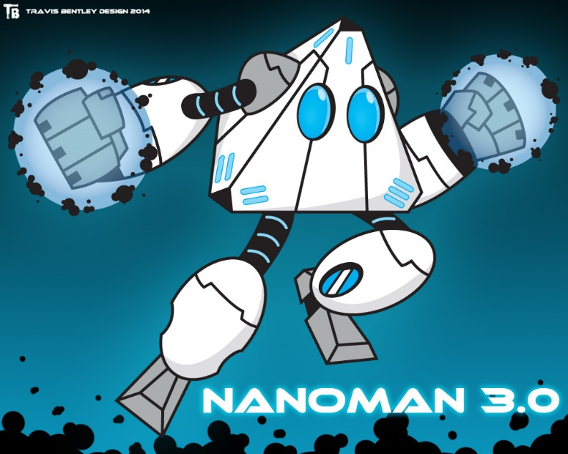

## Background Information

### Creator

Travis Bentley

### Date of Creation

2014

### Terms of Use

“My only terms for the use of this new Nanoman is that no alternation be made to him (color, pose, additions) with my express permission and that credit for this iteration of Nanoman be given to me on social media or websites that use these images with links to my design website [www.travisbentley.com](http://www.travisbentley.com).”

# Contacts

## Template

Street Address   
Position Title of Contact (Last known name of Contact)  
Phone Number  
Email  
Last Contact Year

## Sioux Falls

### Dragons Den

5403 W 41st St  
Position (Name)  
(605) 361-4343  
4/16/2014

### Rainbow Sports Cards and Comic Books

3310 S Minnesota Ave   
Position (Name)  
(605) 338-9519  
4/16/2014

### Hobby Town

1007 W 41st St,  
Position (Name)  
(605) 339-6613  
4/16/2014

### Last Stop CD Shop

3509 W 41st St  
Position (Name)  
(605) 361-4416  
4/16/2014

### Gamestop (Charity Raffle??)

810 Empire Mall  
Position (Name)  
Phone: (605) 361-5505  
4/16/2014

### Universal Bits & Games (Charity Raffle)

3920 S Western Ave  
Suite 2  
Position (Name)  
Phone: (605) 731-8639  
4/16/2014

### Galaxy Gaming

3801 W 34th St  
Suite 105  
Position (Name)  
Phone: (605) 271-0996  
Email: [info@thegalaxygaming.com](mailto:info@thegalaxygaming.com)  
4/16/2014

## Brookings

### Brost’s (Game store)

Closest thing is Brost’s Fashions, a clothing store

## GameStop

2306 6th St  
Position (Name)  
(605) 692-4263  
4/16/2014

## Outside o.o

### Reaper Minis

### Rightstuf! :D:D:D:D (dis fur sure; full page trade for charity raffle items)

### Six Stones

### <http://www.sixstones.com/>

## Madison

### Diary Queen

117 2nd St NE  
Position (Name)  
(605) 256-4042  
4/16/2014

### Sunshine?

215 Van Eps Ave N  
position (Name)  
(605) 256-3541

### Shopko

800 Washington Ave S  
position (Name)  
(605) 256-6169

### McD?

### Lazor Tag :D

### LOOPYS

101 N Egan Ave  
Position (Name)  
(605) 256-2699  
4/16/2014

## Hotel Information

### Super 8 Madison

219 N Highland Ave.

Madison SD, 57042

(605) 256-6931

### AmericInn Lodge & Suites

504 10th St SE

Madison, SD 57042

(605) 256-3076

### Lakes Lodge

19 Golf Drive

Wentworth, SD 57075

(605) 483-3544

### Camp Lakodia?

# SVN

## Overview

The Nanocon SVN contains all documents related to Nanocon. Currently we have everything from Nanocon 7 to the present. The repository works both on and off campus.

The SVN will contain a static version of the website for the associated year.

Email should be archived in the folder for the respective year.

### Permission to Access

In order to use the SVN, the person needs to have an active DSU email. All names need to be submitted to the Gaming Club Advisor (Glenn Berman), who in turn will forward the names to the Director of Web Services. The director will permit access to the SVN for the provided names.

## Setup

### Essential Information

This is a short list of information that is needed to setup the SVN, if you know how to.

#### The SVN location

<https://svn.dsu.edu/svn/nanocon/>

#### Login Credentials

It’s your DSU username (eg. cjhicks) and your password, after you get permission to use it.

### Getting on Computer

#### Windows

1. You can start by visiting the following website: <http://tortoisesvn.net/downloads.html>
2. Click on the button that has your OS type (all DSU computers are 64-bit)
3. Once it is done downloading, open it up, and click on run. The publisher should be Open Source Developer, Stefan KUENG.
4. Now do what you usually do with any other installer, hit next, I agree to terms, next, install etc.
5. Once it finishes installing, go ahead and hit finish.
6. Now, we need to actually get the files from the SVN.
7. In order to do that you should open up Explorer and navigate to where you would like to put the SVN at.
   1. Please do note that the SVN will not create a folder with all the Nanocon stuff in it, so you do need to create a folder specifically for all the stuff.
8. Once you are there, you need to right click and click on the SVN Checkout menu option (This menu item has the text "SVN Checkout ..."  

   There is a yellow cylander with a green arrow coming out of it and pointing outwards towards the bottom left corner.).
   1. If you done get that option, something went wrong with the install, so you should go and ask someone from the NPC to help you out.
9. A checkout window will pop up. You should fill it in as shown below. Your Checkout Directory might be different.
   1. This is the checkout window.  

      On here there are 3 groups of controls.  The first group, called Repository, has 3 fields in it.  The first field is called URL of repository.  In this field you should have the following url in it:  https://svn.dsu.edu/svn/nanocon/

      The second field is where you specify where you want the repository to be stored at.  Once again this might be different from what I have.

      The rest of the controls and field boxes should be at the default values, here are the default values:

      The first Groupbox third control is a checkbox, that I'm not quite sure what it does, but in this image it is a greyed out empty checkbox.

      In the 2nd control group is called Checkout Depth.  There are three items here.  
      The first one is a dropdown, which should be set to Fully Recursive.  

      Then there is a checkbox that says "Omit Externals".  This shouldn't be checked.

      The third is a button that says "Choose Items", This button can be safely ignored.

      The third control group is called Revision.  there are a couple of options here.  

      There is a radio group with two choices.  

      The first choice, called HEAD revision should be choosen by default, if not go ahead and choose it.  

      The second choice has a textbox and a button called "show log".  These fields can be safely ignored.

      At the bottom, go ahead and press OK.
10. Once you are done, hit the OK button.
11. Another window will popup, with the title of “nanocon – Checkout – TortoiseSVN”, as shown below. There isn’t much to this window. It is basically showing you all the files that it has synced from the server in a list.
    1. 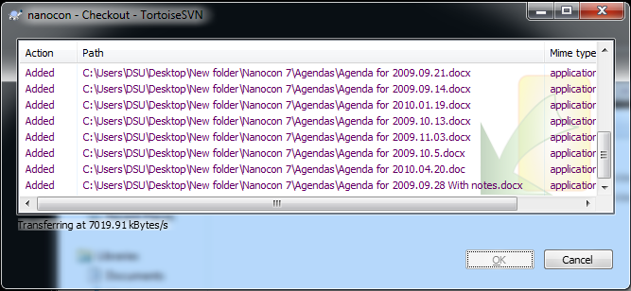
12. Once it is done syncing all of the details, the OK button will be enabled, and you can click it to close out of it.
13. Now if you try navigating to the place you put the SVN, you should see all the files from there.

#### Mac

Here is a rough outline provided by Brian Rushing.

1. open terminal
   1. navigate to desktop
   2. cd ~/Desktop
2. type out the following
   1. svn checkout http://svn.dsu.edu/svn/nanocon
3. This should create folder on desktop called svn. it will show a bunch of file downloads
   1. once done it will say complete.
4. You should now be able to go to the nanocon folder on your desktop.
5. You can add delete files
6. once you do, you need to do the following to update the svn
   1. svn add ‘path to file’
   2. to add a file to the list
7. if just one file, next command is
   1. svn commit -m ‘Some descriptive comment about the change. Make sure to enclose in quotes’
8. You should be good!

#### Linux

Well, if you have a linux box, you should know enough to get this up and running.

## SVN Basics

### Modifying Files

### Upload / Commit changes

## Do’s and Don’ts

This is what you should include and not include in the SVN.

### Don’t

* Commit temporary files (anything starting with ~#)
* Upload a bunch of pictures at once, instead zip them up and upload the entire zip file.
* Leave the Commit comment empty!

### Do

* Upload anything relating to Nanocon to the respective year.
* Document exactly why you are committing the changes and what you did in those changes.

## File Structure

#### Nanocon (Year)

For each New Year, a new Nanocon folder with the respective year is created. This will contain everything related to that year’s Nanocon.

##### aGendas

All agendas need to go in here. The leader of Nanocon has the responsibility to put all agendas in this folder.

##### Letters

If snail mail is to be used, then a copy of that letter must be put into this folder.

##### Minutes

All notes taken during a meeting goes in here. The secretary of Nanocon has the responsibility to put all meeting minutes in this folder.

##### Propaganda

All ads, signs, pamphlets, tickets, logos, and theme ideas go in here.

##### Schedule

This folder will hold all information related to the Nanocon schedule.

##### Vendors

This will hold all vendor contracts and contact information. The Event manager will be in charge of keeping this up to date, and to make sure that everything is correct.

##### website

This will hold the static pages of the website for archival purposes. The website manager for Nanocon is responsible for this folder.

#### Nanocon Website

This is where all the website files and folders go for the current year of Nanocon. Relevant Section Website.

#### Bible.docx

This has all information regarding Nanocon. The basic concept behind this is that once someone reads this document, they should know everything about Nanocon.

# Email Policies

You must use the Nanocon email for any and all official business that requires email contact by the Nanocon staff. It will also be used to register for any and all online accounts.

## Signature

The signature shall use Calibri font. The signature for all Nanocon related emails must include the following:

Name of Sender

-------------------------------

**Official Staff Position**

*Nanocon Staff*

*DSU Gaming Club*

[*www.nanocon.us*](https://webmail.dsu.edu/owa/redir.aspx?C=kgWHf8W41UeHEdZ5yO67TB8BlvkzI9EIFC7NKOcbGCEPj1D_xzjbcYZBQPIJnQYHTuwOzgxb_yY.&URL=http%3a%2f%2fwww.nanocon.us%2f)

### Details

1. Must comprise of dashes with a 10pt font that will completely cover the second line of the signature.
2. The official staff position shall be identical to one of the official titles defined in the Personnel section of this document. It will be bold and have a font size of 12pts.
3. Must state “Nanocon Staff” in italics with a 10pt font.
4. Must state “DSU Gaming Club” in italics with 10pt font.
5. Must state “www.nanocon.us” with a hyper link to “www.nanocon.us” in italics with a 10pt font.
6. May state “Facebook Page” with a hyperlink to the Facebook page.
7. May state “Twitter” with a hyperlink to the Twitter page.
8. May state “Linked-In” with a hyperlink to the LinkedIn page.

## Etiquette

How should all emails be structured?

## Emailing on Behalf of Nanocon

All emails that is sent or received relating to Nanocon must either be cc’d or forwarded to the [nanocon@dsu.edu](mailto:nanocon@dsu.edu).

## Contacts

All Vendors, Sponsors, and Contact info will be up to date in the contact section of the email.

# Concessions

* Before Nanocon
  + Find outside organizations to run the Concessions counter.
  + Schedule outside organization for counter shifts.
  + Schedule Gaming Club members for Concessions shifts.
* At Nanocon
  + Make sure the counter is manned at all times while open.
  + Make sure at least one Gaming Club member is present behind at the counter at all times.
  + Cash out the jar (money) at regular intervals in accordance to the Concessions SOP.
  + Make sure the Concessions SOP is followed throughout Nanocon.
* After Nanocon
  + Update the Concessions SOP as necessary.

## Concessions (food)

### Jack’s Meat Locker

* 250 Hot Dogs (5 cases @ 50/case)
* 56 Meat Sticks (7 lbs. @ 8/lbs)

### Pizzas (from wholesaler @ $2/pizza)

* 84 Pepperoni
* 24 Sausage and Pepperoni
* 25 Supreme
* 36 3-Meat
* 25 Bacon Cheeseburger

### Sam’s Club

* 48 bottle of OJ
* 48 bottle of Apple Juice
* 84 bottles of Chocolate Milk
* Soda (12 packs)
  + 16 Mt. Dew
  + 10 Coke
  + 8 Diet Coke
* Muffins
  + 60 Chocolate muffins
  + 24 Lemon Poppy seed
  + 24 Blueberry
* 1 pack of Chips (50 assorted)
* 8 gal. Chili (for dogs and bowls)

### Sunshine

* 4 case of Water
* 250 Hot Dog buns
* Soda
  + 8 Welches Grape
  + 8 Fanta Orange
  + 6 A&W Root Beer
  + 4 Canada Dry
  + 6 Diet Canada Dry

Baked goods and Puppy Chow provided by Mrs. Bundy

# Concessions SOP

There is to be at least 3 people working the concessions at all times. These 3+ people will consist of at least 1 Gaming Club member and 2+ other people (possible from another organization).

### Tab Sheets

Tab sheets are only allowed to be made for DSU Gaming Club members running events/working the convention, special guests (e.g. guest speakers, vendors, etc…), Lifetime DSU Gaming Club members, and any additional people allowed by the DSU Gaming Club advisor.

Tabs are to be written in by the concessions people only – not the person making the order.

Non DSU Gaming Club member tabs are to be paid by the final day of Nanocon. DSU Gaming Club members may make other arrangements to pay their tabs.

### Safe Drops

Safe drops are to be made regularly throughout the convention using the following schedule:

1. Friday after dinner
2. Friday at close
3. Saturday after lunch
4. Saturday after dinner
5. Saturday at close
6. Sunday after lunch
7. Sunday after dinner
8. Sunday at close

### Setup

#### Initial

* + Extra buns, cups, bowls, etc…. are placed in the cupboards and are brought out as needed.
  + Place the pizza ovens, crockpots, etc…. in their proper places that will be determined based on availability.
  + Fill cooler with pop, milk, juice, and water.
  + Fill freezers with pizza.
  + Place extra hotdogs and other necessary cold items in the fridge.

#### Morning

* + Begin heating chiliand hotdogs.
  + Brew coffee
  + Clean anything not cleaned the night before
  + Inventory Pizza and alter menu as needed.

## Pizza

Each pizza is to be prepared as ordered. Once someone places an order for a pizza rip a standard playing card in half, give the customer one of the halves, and write the kind of pizza on the other half. Then give the half that you kept to the person in the kitchen. When the pizza is done, the card is to be called out so the pizza can be picked up.

*Example: Seth orders a pepperoni pizza. I then grab a playing card and rip it in half. I give one half of this card (we will call it the 3 of clubs) and give it to Seth. I then write pepperoni on the other half and bring it into the kitchen to be cooked. Once it is done I call out “ 3 of Clubs your pizza is ready” so that Seth knows his pizza is finished.*

Reminder: Only one deck of playing cards is to be used at a time. This will prevent confusion and possible overlay of the same card. DO NOT GIVE THEM THE FOOD WITHOUT THE PLAYING CARD.

## Checks

Checks are to be made out to DSU Gaming Club.

## Coffee

Coffee is placed on the front counter near the wall with cups nearby. Guests are allowed to get their own coffee as they desire.

## Cleaning

* Utensils, etc…
  + The utensils used ( such as pizza cutter, ladle for chili, etc…..) are to be cleaned throughout the day during quieter moments and at the very end of the night.
  + By cleaning throughout the day it keeps the mess in the kitchen to a minimum.
* Crockpots
  + The crockpots for chili and hotdogs are to be cleaned out at the end of the day.
* General Kitchen Area/ Front Counter Area
  + Clean these throughout the day and straighten and wipe down at the end of the night.

# Equipment

## RPGA

* Printer
* Computer (with character generator)
* Flash drive
* Clock
* Dividers
* Binders, binders, binders
* Box 'o' dice
* Box 'o' pencils
* Pencil sharpeners
* Paper towels

## Magic

* White board
* Scotch tape

## Video Games

* Projectors
* Screens
* Power strips
* Extension cords
* Tote box
* Wipes

## Reaper

* Paper stub
* Tape
* Contest form tickets
* Minis

## Other - Events

* Events tickets
* Flash drive with ticket papers
* Scratch paper
* Regular Printer paper

## Concessions

* Freezer
* Crock Pots x2
* Pizza cutters x2
* Cleaning supplies
* Pizza oven x2
* Can Opener
* Calculator
* Pens
* Menu
* Decks o' cards
* Speakers
* Microphone (From Playhouse)
* Binder of tab sheets
* Cash box
* Pizza trays/tin foil x3
* Chili serving stuff

## Convention Hall

* Signage from ceiling/walls
* Sharpies
* Schedule boards
* Front table
* Con badges
* Garbage Cans
* Recycling Bins (From TC)
* Paper Towels
* Garbage bags
* Post-its
* Frebreeze

# Convention Hall Layout

The layout of the convention hall can be found on the next page.

## Rooms

### Primary Convention Room

This room is around 80 x 80 feet. This is where most of the events happen. It is in here that you can find the following: ACME, Hobby Town, RPGA, Flash Bax, Silver Gryphon, SIS, Dragon’s Den, Artist’s Alley and table top games.

### Main Hall

The main Hall is the high traffic area. This is where guests get their badges, tickets, order some food, and find the bathroom. One can get to the bathrooms in this hall. There must be a sign indicating where the bathrooms are. Other things that you can do here is take a photo and play console games.

### Theatre

This is where all our guest speakers go to talk. The Game Design Majors on campus do display their current progress on their games here.

### Concessions

This is technically part of the Main Hall, but it is distinct enough to separate out. It is here that we make the pizzas and sell snack and food items.

## Updating the Layout

The person to contact is the

Size: 80’x80’

# Maps

## Main Lobby



## Main Hall & Theatre



# Areas

## Front Table Area

This area was traditionally handled by the Martial Arts club here on campus. They no longer have a club on campus, so Anime Club stepped in to fill this spot, after the President (Bryce Blocker) volunteered the club for this position, without asking the club first.

The basic idea behind this area is to hand out the Nanocon booklets and lanyards, keep track of lost and found, and as a general Q&A area.

## Game Consoles

### Before Nanocon

Schedule events.

Acquire necessary equipment.

### At Nanocon

Give all event organizers their respective event organizer packet.

Make sure all event organizers are aware of the event procedure.

Make sure all event organizers are at their designated feature table at their designated time.

Field any schedule changes, and alert the On Site Schedule Manager of any changes (including new events).

### After Nanocon

Make sure all equipment is returned.

## SIS

SIS, or Society in Shadows . . .

* Before Nanocon
  + Contact Six Stones to confirm their attendance and get a contract quote.
  + Inquire about and schedule events they wish to run.
* At Nanocon
  + Field any schedule changes, and alert the On Site Schedule Manager of any changes (including new events).
  + Manage player disputes.
  + Inform Six Stones personnel that they may run a tab at the concessions counter.
  + Get the final contract from Six Stones, and deliver to Paperwork Manager.
* After Nanocon
  + Send Thank You letter to Six Stones for their participation.

## Role Playing Gaming Area

* Before Nanocon
  + Print all necessary modules that can/will be run.
  + Schedule RPGA/RPGA area events.
  + Schedule GMs for events.
  + Work with Czar of Propaganda and Nanocon Manager to create event tickets.
  + Field any schedule changes, and alert the On Site Schedule Manager of any changes (including new events).
* At Nanocon
  + Make sure all GMs are aware of the event procedure.
  + Organize the RPGA area tables as needed.
  + Make sure GMs are present to run all events.
  + Maintain organization and cleanliness in the RPGA area.

## CCG Tournament

CCG, or ??? is ???.

* Before Nanocon
  + Contact outside organizations to host CCG events.
  + Inquire about and acquire any special equipment they may need.
  + Inquire about and schedule events they wish to run.
  + Work with Czar of Propaganda and Nanocon Manager to create event tickets.
  + Get the organization into the DSU payment system if they are not already.
* At Nanocon
  + Give all event organizers their respective event organizer packet.
  + Make sure all event organizers are aware of the event procedure.
  + Make sure all event organizers are at their designated feature table at their designated time.
  + Field any schedule changes, and alert the On Site Schedule Manager of any changes (including new events).
* After Nanocon
  + Send Thank You letters to all outside organizations that hosted CCG events.

## Gaming Area

* At Nanocon
  + Keep the cabinets clean and organized.
  + Make sure any game taken from the cabinet is returned and not damaged.
* After Nanocon
  + Make sure all games are returned, complete, and organized (both in their respective boxes and in the cabinets).

## IDiG

Integrated Design in Games or IDiG for short is responsible for handling guest speakers. They have been around since 2010. Usually Jeff Howard and Steve Graham heads this effort. They must coordinate with the speaker, be able to readily provide information about DSU and Nanocon, coordinate the travel and lodging, set up the presentation schedule, create a short bio on the speaker, and create a short description of what they will be talking about. They must make sure that the speakers have any and all the equipment that they might need.

### Speakers

### Hotel & Board

The hotel should be contacted before October to reserve the rooms for the speakers. The hotel contacts are in the Contacts section.

### Presentation

You need a presentation title and a short description about what the presentation is about.

### Bio

Every speaker needs to have a bio for both the website and the booklet. The bio should include the person’s name and current position. A list of games that they have worked on is a must. The bio should also include a short piece about who the speaker is, what he is known for, and any notable games that they have worked on.

### Contracts

The actual contract is in the @@@@ section. In order for speaker to speak, they must sign this contract. (Brief overview of what contract states).

### Scheduling

The scheduling master must be notified of any changes in a presenter’s schedule.

### At the Con

### Minions

Minions do not come into play until the presenter arrives in Madison or Sioux Falls.

* Before Nanocon
  + Acquire and confirm guest appearances.
  + Coordinate travel and lodging.
  + Set the presentation and workshop schedule.
  + Get presentation and workshop descriptions for the online and booklet schedule.
  + Inquire about and acquire any special equipment the presenters may need.
  + Schedule door workers to take tickets for presentations/workshops.
* At Nanocon
  + Schedule any transportation to and from Nanocon as necessary.
  + Inform presenters that they may run a tab at the concessions counter, if they so choose.
  + Inform the presenters in a timely manner when they are scheduled to present (i.e. fifteen minutes before their scheduled presentation/workshop).
  + Hand out contracts to all applicable presenters to sign and return (can be mailed in after Nanocon).
  + Make sure the door is manned at all time with someone taking tickets for the presentation/workshop.
  + Field any schedule changes, and alert the On Site Schedule Manager of any changes (including new events).
* After Nanocon
  + Send Thank You messages to all presenters.

# Bible Writing Conventions



## Referring to People

Any time a person needs to be contacted, their official position must be used, and then in parenthesis, the person last known to hold that position. For example: In order to gain access to the SVN you need to contact the Gaming Club Advisor (Glenn Berman) and request access to it.

## Formatting

All sections must start on their own page. A sub-section should never be split in two by a page break.

## Updating

It is the responsibility for each officer to update his or her section at the end of each year, to ensure that the Bible stays up to date.

Any person who makes changes in this document must update the date under the Nanocon logo on the first page. This date is there to indicate when it was last updated.

Be sure to add your DSU credentials to the author section of the document.

# Authors

**amthiele**

**cjhicks**

**lamutzenberger**

**bnrushing**

**rgroth**

# Title Page



1/16/18